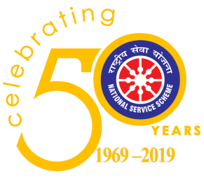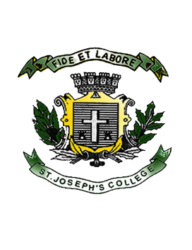**ST. JOSEPH’S COLLEGE (AUTONOMOUS)**

**BANGALORE**

(Re-accredited by NAAC with A++ Grade at 3.79/4.00 by NAAC,

College Of Excellence)

To,

Dr.Ravikumar Surpur, IAS

Special Commissioner

Respected Sir,

**Sub: Invitation to be part of the N.S.S. Inauguration Ceremony**

Greetings from St. Joseph’s College (Autonomous) Bangalore, 137 year old college seeking to form men and women who will be agents of change, committed to create a society that is just, secular and democratic.

National Service Scheme of St. Joseph’s College (Autonomous) established in 1969 also known to be one of the oldest NSS units in Karnataka State have successfully completed its fifty years, reflecting the essence of democratic living and upholding the need for selfless service, empowering youth to promote National Integration.

With immerse pleasure; we cordially invite you to be the Chief Guest for the Inauguration Ceremony.

**Date: 27 June 2019**

**Timings: 4:30 Pm onwards**

**Venue: Xavier Hall (PG Section)**

We eagerly look forward to your presence.

Thank you.

Yours’ Sincerely

Prof. Selwyn Paul. J

N.S.S. Officer

St. Joseph’s College